What are the effects of Covid- 19 on professional football?

**An analysis of the influences of “ghost games” on home advantage**

**Master thesis Marketing Analytics Spring 2020**

**Name: Alan Rijnders**

**SNR: 2063482**

**Date: 30-03-2021**

Contents

1 Introduction 1

1.1 Problem Indication 1

1.2 Research Questions 3

1.3 Research Approach 3

1.4 Academic Relevance 3

1.5 Managerial Relevance 4

1.6 Structure of Thesis 5

2 Theoretical Background 6

2.1 Literature Review 6

2.1.1 The role of home advantage in sports........................................................................6

2.1.2 The role of home advantage in football.....................................................................6

2.1.3 Home advantage during covid-19..............................................................................9

2.2 Theoretical Framework ..... 12

2.3 Conceptual Model 15

3 Method 16

4 Analysis and Findings 17

5 Conclusions and Recommendations 19

5.1 Conclusions 20

5.2 Recommendations 20

5.3 Future Research 20

6 Bibliography 21

# Introduction

## Problem Indication

Football is the most popular sport in the world with millions of players across the Globe. According to a study conducted by FIFA (2006), the amount of active football players was 265 million (FIFA 2007). In other words, roughly 4 percent of total world population at that time was regularly playing football. The amount of fans is even more staggering, with 3.5 billion people tuning in for the FIFA World Cup Final in 2018 between France and Croatia for example (FIFA, 2019) .

Many of these fans were left without their favourite pastime for a considerable time when the Covid pandemic struck Europe and other parts of the world in March 2020. Due to strict measures and even complete lockdowns in several countries, almost all sports games were cancelled or postponed until further notice. After a few months of lockdown, the Bundesliga was the first major league to restart their competition to finish the remaining quarter of the games. On the 16th of May the Bundesliga recommenced with a packed schedule featuring 6 matches behind closed doors. Other major European leagues such as the Premier League, Serie A and La Liga followed soon and there was even some space in the packed playing calendar to finish the remaining knock-out matches of the Champions League and Europa League. Global social distancing measures following the Covid-19 pandemic introduced the phenomenon “Ghost Matches” in the football world during the restart. So called “Ghost Matches” are football matches without any spectators attending. Without the fans attendance the matches seemed mere training games, which gives rise to the question what sort of influences this could have on the the outcome of matches. Is home advantage still present in games without a crowd? Is referee behaviour different without fans? Do away teams perform better under the new circumstances? We aim to answer these questions in this paper.

Due to its popularity, an abundant base of research on football and each of its aspects currently exists. The same holds for the possible advantage of the team playing at home, with several papers trying to disentangle the dynamics at play that could lead to home advantage. (e.g. Boyko, Boyko & Boyko ,2007; Pollard & Polla[rd, 2005](https://shapeamerica.tandfonline.com/doi/full/10.1080/02640410601038576?scroll=top&needAccess=true)). Examples of previous research topics include, does the crowd raise home team performance? Or is the performance of away teams significantly lower in hostile environments? Goumas (2014) finds that home teams on average win more games, collect more points and score more goals than away. However, whether this is a result from deteriorating away performances, better home performance or a combination of both is not clear yet. Another factor involved in home advantage is the referee. A referee has a large influence on the outcome of the games (Boyko, Boyko & Boyko, 2007). Especially in a sport as football which has such a low scoring nature(Decroos, Bransen & Davis, 2019). A decisions to award a team a penalty in the 89th minute of the match with the score of 0-0 could completely change the match outcome. Or an early red card significantly alters the course of the match with both teams adjusting their tactics and strategy. Neville & Holder (1999) and Bokyo (2007) find that crowds could influence referee decisions subconsciously in favor of the home team. This is favoritism is often named the “referee bias”. A term we will use as well in our research from now on. Endrich & Gesche (2020) quantify the referee bias in their paper where they find that away teams on average receive 0.3 cards less and home teams 0.5 cards more per match when there are no spectators.

Home advantage seems to be in decline however in general, find that home advantage has declined over time from(Peeters & van Ours, 2021). One of the major factors they prescribe this decline to is the bigger distance between fans and players, with most of the players coming from countries spread around the world, presumably less connected to the local fans who are used to supporting their local heroes. (Pollard 2006; Smith 2003).

Opinions on how and to what extent home advantage is shaped by crowd support are very mixed. In light of the uncertainty in the effect of crowd support, the current extraordinary circumstances thus provide a special occasion to increase our understanding of the relevance of crowd support and its influence on referee behaviour and player performance. Furthermore, the effect of moderating variables on team performance can be directly investigated. Examples of these could include the composition of teams in terms of foreign and local players, crowd size, team age and crowd occupancy.

## Research Questions

This natural experiment translates into the following leading research questions:

* + 1. To what extent is referee behaviour shaped by crowd support?
    2. To what extent is home and away team performance significantly different as a consequence of “ghost games”?
    3. To what extent does referee bias influence team performance?

## Research Approach

Providing legitimate answers to the aforementioned research questions requires a combination of theoretical and empirical analysis. Firstly, we examine the current and historical literature to obtain information on the relationship between crowd attendance and team performance. This will serve as our basis on which we can conduct the right analytical approach to analyze our data.We decide to include the seasons 2018/19, 2019/20 and 2020/21 into our final analysis, this results in a roughly equal division of ghost games and non ghost games in our data. Furthermore, around 2018, the VAR got introduced in most of the matjor league in Europe, possibly changing our results on referee behaviour significantly.

We then combine match data with a data set from Fivethirtyeight to incorporate expected goals as extra measures of performance and home advantage. This data set also contains team strength and match importance which we can include as control variables into the analysis. The data for our moderator variables, team age, amount of foreigners and stadium occupancy are collected manually from Transfermarkt.com. This website provides a vast amount of detailed statistics on players, clubs and leagues.

## Academic Relevance

The batch of matches without fans provides an unique opportunity to delve deeper in the impact of crowds on football matches since there is an abundance in new data for matches played without crowds. Past papers often required advanced econometric techniques, relying on various assumptions, to be able to discern the extent to which a crowd influences home team advantage. The difficulties in assessing drivers of home advantage lies in confounding variables effects (Pollard , 2008). This makes it unclear how much of home advantage can be attributed to what factors since most of the factors of home advantage are connected to each other. However, in the current situation, suddenly there are substantial amounts of data on “ghost games” which can be used to directly compare matches with and without spectators, which reduces the number of assumptions to be made significantly.

A few papers on home advantage in times of covid-19 have been published already, including the work of (Fischer & Haucap, 2020;Deutscher & Winkelmann, 2020; Endrich & Gesche, 2020). They analyzed the home advantage during the covid-19 pandemic. However,each of these papers focused on German leagues in their analysis. We add to the current research by extending the preliminary research already completed to numerous other football leagues to obtain a comprehensive overview of the evolution of home advantage during the pandemic. Also when compared to preliminary studies on home advantage our paper uses the extended availability of data for games played behind closed doors available in the 2020/21 season. Papers from last year mostly only use data from the 2019/2020 season which was partly played under normal circumstances and partly played behind closed doors. Incorporating data from 2020/21 into the analysis increases the sample size and decreases confounding effects resulting from possible biased schedules in partial seasons.

Furthermore, we contribute to the current body of literature by constructing a comprehensive framework of the influence of crowd support on home advantage by using several mediating and moderating variables to assess how and to which extent crowd support influences home advantage.

## Managerial Relevance

Covid affects the footballing world in multiple ways. The absence of crowds plus the extra heavy loaded schedule increase uncertainty surrounding team and individual performance(Metelski & Kornakov, 2021). However, the influence works through on football clubs off the pitch. Team performance heavily influence team results. Team results in turn influence a clubs performance outside of the pitch in several ways. To name 2 examples, Samagaio, Couto & Caiado (2009) mention a positive relationship between on pitch results and stock performance. Moreover, increased team performance leads to increased market value for players (Müller, Simons & Weinmann, 2017). Similar findings are reported by (Galariotis, Germain & Zopounidis, 2018 ; He, Cachucho & Knobbe, 2015). Both studies find positive relationships between revenues and position in the league table as well as between revenues and individual performance. Therefore, estimating the influence covid-19 has on team performance and football results will help football clubs evaluating the effect of the pandemic on their marketing, financial and on-field performance.

Knowledge on what variables exactly drive home advantage and team performance provides great insight for football clubs in how to optimize their clubs environment and team to improve the chances of performing well. Fischer & Haucap (2020) for example see a significant effect of crowd occupancy on home team performance by comparing home advantage during covid-19 between the German Bundesliga and the 2nd and 3rd level of German football. Similary, Goumas (2013) and Nevill, Newell and Gale(1996) find evidence for increased home advantage for teams playing for larger crowds.

Stadium occupancy and crowd size can be influenced by managers through several channels. Wetzel, Hattula, Hammerschmidt & van Heerde (2018) show for example that football clubs possessing a stronger brand name can leverage this brand name to increase attendance, an effect which increases over time of the existence of the brand. Creating a stronger brand could increase higher attendance rates, higher matchday revenues and better team performance. Another variable that is under control of management and possibly related to team performance differences in home and away matches are the age of the squad players and the composition of the squad in terms of local and foreign players. Prior research conducted by van de Ven (2016) signal a small effect of age on team performance, with older teams performing slightly better away than younger teams. We aim to examine whether a football club branding their club to their supporters as an experienced squad with local players can increase the teams performance.

By examining the effect of variables such as crowd occupancy and team composition on home performance, we aim to provide marketeers direct tools to influence the performance of their clubs. Hypothetically speaking, knowing that improving the occupancy rates for their team increases team performance gives the marketing department a significant task in finding ways to attract more fans to the stadium. Perhaps,even a slight decrease in ticket price with the associated lower per customer revenue could actually turn out as a smart investment with better team performance and an upwards positive spiral both on and off the field. We believe the current literature is lacking in this area. Most of the papers available on this topic refrain from applying their findings to managerial recommendations for football clubs.

## Structure of the Thesis

This first chapter serves as a background chapter for the rest of the thesis in which we outlined the concept to be researched in combination with the academic and managerial relevance of the concept. In the second chapter we construct the theoretical framework that will represent the basis of the empirical analysis in the later sections. First, we analyze the current literature to obtain an overview of what is currently known. In chapter 3, having laid out the theoretical framework, we thoroughly describe the data set and the variables we use to define the concepts that we want to analyze. Furthermore, based on our variable selection and data structure, we select the most suitable method of analysis to attain the desired results and answers to our research questions. In the fourth chapter we summarize the analysis and findings of the research in order to answer the empirical questions. Furthermore, we extend our model with several robustness checks to ensure that our findings are actually meaningful and not a result of flaws in our methodology or reasoning. Finally, in the fifth chapter, we generate conclusions and recommendations based on the findings of the study. We use this chapter to provide football club management with deeper insights into the drivers of their team performance at home, and how these can be influenced by management. Additionally, we discuss the limitations of this study and provide a guideline for possible future research in this area to improve our understanding of home advantage even further.

## Theoretical Background

## Literature Review

## 2.1.1 Crowd support and home advantage

Home advantage has been widely studied in the literature. One of the first to formally document the existence of a certain home advantage in sports were Schwartz & Barsky (1977). They find that home advantage exists in varying degrees across different sports. In their research they suggest that the major contributor to home advantage is social support as they find a strong relationship between audience size and home advantage. Nevill and Holder (1999) support this claim as they produce similar results in their analysis of home advantage in English and Scottish football matches. Ponzo & Scoppa (2018) in turn argue that a home crowd can be a positive stimulus for home team players and can create an intimidating and hostile environment for the opposition . Home team performance is raised relative to away team performance as their effort and and energy is stimulated by the positive support from the crowd . Ponzo & Scoppa base their conclusions on the analysis of same stadium derbies in Rome and Milan to mitigate other possible factors of home advantage such as traveling and familiarity effects. They find that when controlling for referee decisions and other factors such as team strength, the home team still performs better in the local derby.

An interesting question then arises whether all teams experience a similar boost from their home crowd or that certain team characteristics or crowd characteristics could be associated with higher levels of home advantage. Each home crowd is unique, crowds differ substantially in size, density and also fanaticism. Carron and Agnew (1994) find a significant positive relationship between home advantage and crowd density. In other words, more crowd support leads to a stronger home performance relative to away performance and consequently a higher chance of a home win than an away win. Fischer & Haucap (2020) also find that there seems to be a significant alteration in the strength of home advantage due to differences in crowd occupancy. They found a significant decrease in home advantage in the Bundesliga when crowd support is absent. However in the 2nd Bundesliga and 3rd Liga home advantage did not change significantly during ghost games. They account this difference to the differences in occupancy rates between these competitions.

However by other researchers, some questions have been raised as to whether crowd size and occupancy actually are important. Pollard (1986) negates the importance of crowd size and crowd density. In his argument he uses the notion of a similar magnitude in home advantage across first and second divisions across Europe. Despite the vast differences in crowd size and often also crowd density between first and second divisions, the home advantage still persists. Furthermore, Salminen (1993) and Strauss (2002) claim that crowd support in the form of cheering does not affect team performance. In fact, they even find support for the case that teams are motivated by non supportive audience and play better in such situations.

Different results seem to occur because of the difficulty in disentangling each of the various forces driving home advantage. Pollard (2008) explains that struggles concerning the unraveling of individual factors effect on home advantage sterns from the phenomenon that multiple psychological and physiological influences involved all interact with each other and possibly reinforce each others significance. For exactly this reason do “ghost games” provide such an unique opportunity to specifically study changes in home advantage as a consequence of crowd support. Therefore we use “ghost games” to examine whether crowd occupancy and crowd size significantly affect team performance.

Apart from directly raising home team performance,crowd support is said to afffect team performance through the referee. Multiple studies including: (Nevill, Balmer & Williams, 1999 ; Nevill, Balmer & Williams, 2002; Garicano, Palacios-Huerta & Prendergast, 2005; Unkelbach & Memmert , 2010; Sutter & Kocher, 2004) find consistent evidence of a referee bias in favour of the home team probably due to social pressure from the crowd. Examples of this bias include the issue of more stoppage time at the end of the first and second half when the home team is trailing. In more recent research Endrich & Gesche (2020) find that referees give less cards and fouls to home teams and more cards and fouls to away teams on average, which could be interpreted as a sign of referee bias in favour of the home side.

Previous studies found evidence that crowd cheering and noise are the main contributor to referee bias (Endrich & Gesche, 2020; Nevill, Balmer & Williams, 2002; ) Referees can be heavily influenced in their decision making by the heavy cheering of the crowd favoring the home team.(Unkelbach & Memmert , 2010). Experiments conducted by Nevill, Balmer and Williams (2002) show the role of crowd noise by asking participating referees to evaluate fouls. One group of the referees were shown the fouls with sound of the cournd in the background whereas the other group watched the fouls in silence. The referees watching with crowd noise on average gave 15 percent less fouls to the home team compared to referees watching in silence. Referee bias and crowd noise is well documented in the literature. However, there is less empirical research on to what extent crowd size and occupancy influence referee decisions. Research like ours on the incidence of referee bias in ghost games settings could provide useful in discerning whether or not crowd size and occupancy play a role in referee decision making. Furthermore, most of the papers tended to focus solely on the existence of referee bias rather than on the implication of a possible referee bias on team performance. We extend the current literature by incorporating the influence of referee decisions on team performance into our analysis.

## 2.1.2 Team composition and home advantage

Another stream of the literature on home advantage focuses on familiarity effects. Pollard (2008) describes familiarity effects as key stadium attributes that could help players locate themselves more precisely on the pitch and consequently make better decision on where and how hard to pass the ball or where to position themselves to get the best shot on goal. Older players who have more experience, especially when that experience is within the same league, will be more familiar with venues and could have similar advantages as home team players in visual cues when playing away. The concept of familiarity can also be extrapolated to the realm of crowd support. This school of thought has not been widely studied yet but studies such as that of van der Ven (2016) report a slightly better away performance for older teams, compared to teams with more younger players. Older teams could be more experienced with facing home crowds, which in turn could decrease the effect of these crowds on their performance. Russell (1983) for example finds that older players develop certain coping strategies to deal with the influence of the crowd on their performance.

A different component of team composition that could influence the effect of crowd support on team performance is the amount of foreign players featuring for the teams. In the increasing globalized world, international transfers are increasingly common, leading to an influx of foreign players into squads of football clubs. (Adcroft, Teckman & Madichie, 2009). These foreign players, with increasingly high salaries are difficult to relate to for local often working class football supporters. (Petersen-Wagner, 2015) This leads to fans and players becoming more and more detached from eachother, decreasing the bonding between fan and players. Gutierrez (2019) claims that this bonding process between fans and players is a crucial component for fan engagement and consumption. Increased fan engagement leads to a better atmosphere and louder crowds. Lee, Gipson and Barnhill ( 2017) provide further evidence for the influence of fan identification with their team. They surveyed attendants of basketball and baseball games in the NCAA division. They found that measures of team identification significantly influenced crowd atmosphere through an indirect effect on flow of supporters, with flow being defined following the definition of Csikszentmihalyi (1990): "the state in which people are so involved in an activity that nothing else seems to matter”. Their findings suggest that a decreased identification of supporters with their team decreases atmosphere within the stadium. The difference in atmosphere within the stadium could influence team performance.

## 2.1.3 Covid-19 and home advantage

A few preliminary studies attempted a similar approach to ours by analyzing “ghost games” played between the restart after corona and the end of the season 2019/20. Thilp & Taller (2020) for example find that home advantage has actually turned into a home disadvantage in case of “ghost games”. Fischer & Haucap (2020) also support the notion of a signifcant alteration in the strength of home advantage in the Bundesliga when crowd support is absent. McCarrick, Bilalic, Neave and Wolfson (2020) report similar findings in their study of home advantage across 11 countries. They discovered that across those leagues the number of goals scored and points obtained by home teams was significantly lower in the period of corona. However, apart from McCarrick et al (2020), most of the recent papers only include one single country into their analysis, we believe that this approach is limited because single countries could be an anomaly. Especially when the data is also limited to only the end of the 2019/20 season. Within this smaller sample, a few abnormal results could already influence conclusions. We incorporate multiple countries in our dataset and extend the analysis to all the “ghost games” played up to date to obtain a larger sample and more generalizable results. The table below gives a short overview of the current literature and our contribution.

**Table 1 Summary of Literature**

## Conceptual Framework

## 2.2.1 The impact of crowd support on team performance

We propose two major mechanisms on how crowd support influences team performance. Firstly, crowd support can raise home team performance relative to away team performance directly through cheering and booing. Crowd support can inspire home teams to perform to their potential, increasing home team performance. Secondly, crowds are able to influence referee decisions in favour of the home team. Crowd noise significantly influences referees when evaluating potential foul situations. For these reasons team performance could be lower when in a situation of no or less crowd support.This leads us to generate the following hypothesis regarding the effect of crowd absence on home advantage.

*H1: Crowd support positively influences Home Team Performance.*

Crowds come in all shapes and sizes and different crowds will have different influences on team performance. Bigger crowds in general make more noise and can be more initimidating than smaller crowds. The is a big difference in playing for large crowds compared to small crowds. Crowd support has a direct effect on team performance and a larger crowd size is associated with larger crowd noise. This larger crowd noise and size could boost confidence of the home team, knowing they have got the backing from so many fans, and thus could lead to larger performance boosts for home teams relative to away teams. Therefore we construct the following hypothesis on the effect of crowd size on team performance.

*H1b: The effect of crowd support on team performance increases when crowd size increases.*

Crowd occupancy is also important for atmosphere within a stadium, and in turn the effect of crowd support on team performance support. Fischer & Haucap (2020) find that teams with higher occupancy rates pre corona experience a greater decrease in home advantage post corona. If you play for 30.000 fans in a stadium where 100.000 fit, the atmosphere seems to be less intense and the stadium can appear to be almost empty. The switch to a completely empty stadium in this case might be less severe than a case where 15.000 very fanatic fans completely fill up a small stadium with stands close to the pitch and a fiery atmosphere. A completely empty stadium all of a sudden makes a very big change. This change will affects on team performance and therefore we hypothesize the following on the effect ofstadium occupancy on team performance.

*H1c: The effect of crowd support on team performance increases when Stadium occupancy increases.*

The degree to which Crowd support will influence team performance will vary per team. Each individual player reacts differently to playing environments. Team composition seems to play a role. (van de Ven, 2016) finds that experienced sides with older players tend to perform better away from home than inexperienced sides. Possible reasons could include familiarity with the away venue and more experience with hostile crowds. Older players who have more experience, especially when that experience is within the same league, will be more familiar with venues and could be more experience with home crowds. Older player develop can develop coping strategies to decrease the influence of opposition crowds on their performance when playing away (Russell, 1983). This leads to the following hypothesis of the effect of age on the relationship between crowd support and team performance.

*H1d: The effect of crowd support on team performance is weaker for teams with older players.*

Similarly, Tilp&Taller (2020)mention an increased global outlook of football clubs, both for recruiting fans and players as a factor, which has lead to an increased gap between fans and players. Fans and players due to the increased differences in pay and origins live in completely different realities from each other. Fans do not recognize themselves in the extremely rich and foreign players who play for their local team, Lower fan identification with a football team decreases the support of those same fans when attending the match. This decreases crowd cheering and thus indirectly decreases the effect of crowd support on team performance. This leads to the following hypothesis regarding the effect of share of foreigners within a team on team performance.

*H1e: The effect of crowd support on team performance is weakened when the share of foreigners increases.*

## 2.2.2 The impact of crowd support on referee bias

Referees have shown a consistent bias towards home teams when awarding fouls and cards. Referees are subconsciously influenced by crowd noise when making decisions on potential fouls, cards and penalty’s. Punishing home teams less severe in situations with crowd noise. Potential explanations include the use of visual cues in decision making when the situation is not very clear, with crowds reaction to a foul serving as a potential indicator of the actual situation and referees relying partly on these crowd judgements when making a decision. Additionally,referees could favour home teams in order to avoid potential crowd displeasure aimed at him during the rest of the game and even after the game. In football, much more compared to other sports, one action can decide the entire game. A 1-0 win with a single shot on goal is certainly attainable. Additionally, a red card can change a teams entire game plan, tactics and performance.

Since individual moments can have such a big impact on outcome and performance in football, referees play a major role in football outcomes. Crucial decisions such as a controversial penalty or red card can significantly alter the course of a football game, and if the home team gets benefit of the doubt it could significantly increase the chances of home teams winning their games. This leads to the following hypothesis on the effect of referee bias on team performance.

*H2: The effect of crowd support on team performance is mediated by Referee Bias*

Similar to the expected moderating effect of crowd occupancy and crowd size on the direct relationship between crowd support and team performance, we expect crowd occupancy and crowd size to influence the relationship between crowd support and referee bias. (Nevill, Balmer & Williams, 2002) demonstrated in an experimental setting the significant effect of crowd noise on referee decision making. Referees are more uncertain in their decisions when crowd noise is present compared to situation where there is silence only. Often more favoring the home team in a situation with crowd noise by being more lenient in fouls . Therefore we expect that a higher occupancy and a higher crowd size, with more crowd noise will result in a stronger referee bias towards the home team. This leads to the following 2 hypotheses.

*H2b: The mediating effect of referee Bias on the relationship between crowd support and team performance increases when Stadium Occupancy increases.*

*H2c: The mediating effect of referee Bias on the relationship between crowd support and team performance increases when average Crowd Size increases.*

Similar to the expected moderating effect of share of foreigners within a team on the direct relationship between crowd support and team performance, we texpect he share of foreigners within a team to influence the relationship between crowd support and referee bias. Teams with a high share of foreigners will be difficult for the home crowd to bond with their own team, producing a less intense atmosphere in the match and consequently the crowd noise is less. Since referee decisions in favour of home teams are influenced by crowd noise and crowd reactions, we expect that their decisions will be less in favourable for home teams when the crowd noise is lower. Therefore, we construct the following hypothesis.

*H2d: The mediating effect of referee Bias on the relationship between crowd support and team performance decreases when the share of foreigners increases.*

Figure 1 shows the conceptual model we establish based on the current literature and hypotheses. This conceptual model will be used in later stages to build the correct model to analyze the data. **Figure 1** 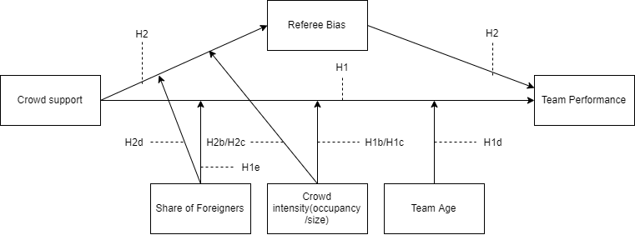

## Data and Methodology

## 3.1 Data collection

The website: <http://www.football-data.co.uk/data.php> has weekly updated datasets for all important leagues around the world. The datasets include statistics on full-time and half-time results, shots, shots on targets, number of fouls, number of yellow and red cards and corners for each team on match level. Our sample includes all the matches played from season 2018/19 onwards, with each match appearing exactly once in the dataset. We chose 2018/19 as cutoff since the VAR got introduced around this time in most competitions.([1]) Var has major implications especially in the realm of crowd supports influence on decision making by referees. The referee can be overruled by the video referee, often located outside of the stadium, and thus less influenced by crowd noise. We decided to analyze the 9 of the top 10 leagues in Europ for purposes of data availability and data convenience. The 9 leagues incorporated are: Dutch Eredivisie, German Bundesliga, Portuguese Primeira Liga, The Turkish Super Lig, Belgian Jupiler League, French Ligue 1, English Premier League, Spanish Primera Division. We added a dummy variable equal to 0 for the leagues where the VAR had not been introduced yet in a particular season, which was the case only for the 2018/19 Premier League and 2018/19 Primeira liga seasons. For data on our 3 moderators: team age, proportion of foreigners playing for the team and crowd occupancy, we consulted the website of transfermarkt.com.

We use multiple measures of team performance as dependent variable in our analysis. Team performance depends heavily on the quality of the team (Lago-Peñas & Lago-Ballesteros, 2011). Thus a measure of team strength should be included in the model as control variable. The most comprehensive measurement of team strength we know is the SPI index used by FiveThirtyEight[2]. Their SPI index is constructed by computing an offensive rating and defensive rating. This rating is equal to the number of goals expected to score/concede by the team against an average opponent on neutral ground. The SPI then is the percentage of points that the team will take if the match against an average team on neutral ground is played. FiveThirtyEight’s public github repository provides weekly updated dataaset with SPI data. Another factor important to incorporate is match importance. Link & de Lorenzo (2018) discovered that players and make more faster runs and more fouls in matches that were influential on final ranking compared to matches which were not. The SPI dataset also includes a measure of match importance for both the home and away team. The match importance is calculated through expected probabilities of each match outcome that would alter the ranking of the team in the competition. For many variables we use the differences between home and away metrics within the match to reduce the number of variables used in our models.

## 3.2 Variable Operationalization

**Table 2 Variable operationalization table**

## 3.3 Descriptive statistics

Table 3 provides the descriptive statistics for the variables mentioned in section 3.2.

The data set contains match data for 8137 matches played in 9 major leagues of Europe. On average in the last 3 seasons, home teams won 56 percents of total points per match. Similarly, the number of home points on average is 1.557 points per game collected on home, while the average number of away points equals 1.192.

**Table 3 Summary Statistics**

## 3.4 Home advantage pre and post covid-19

For the entire sample, there is a clear home advantage, with more points, more goals and more expected goals for home teams. However, solely based on the entire sample we cannot conclude whether home advantage has remained during covid-19. Therefore we split the dataset into two different datasets with one dataset containing matches only played before covid-19 and the other only containing matches played after covid-19. 2996 of the matches have been played behind closed doors and 5141 were played with spectators present.

Figure 2 shows a clear difference in the percentage of total points obtained by home and away teams per match. The average over all matches for home teams has decreased from 57.72% to 53.28% whereas away teams percentage conversely increased from 42.28% to 46.73%.

**Figure 2 Comparison of percentage of total points for home and away teams**

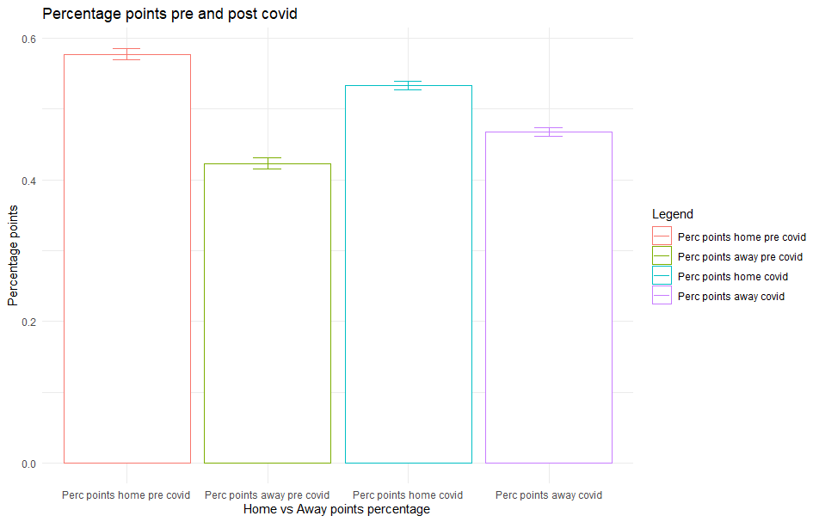

Both Expected goal and actual goal differences between home and away have been halved since the beginning of the covid-19 pandemic, showing a decreased gap between home and away teams.

**Figure 3 comparison of goal and expected goals gap**

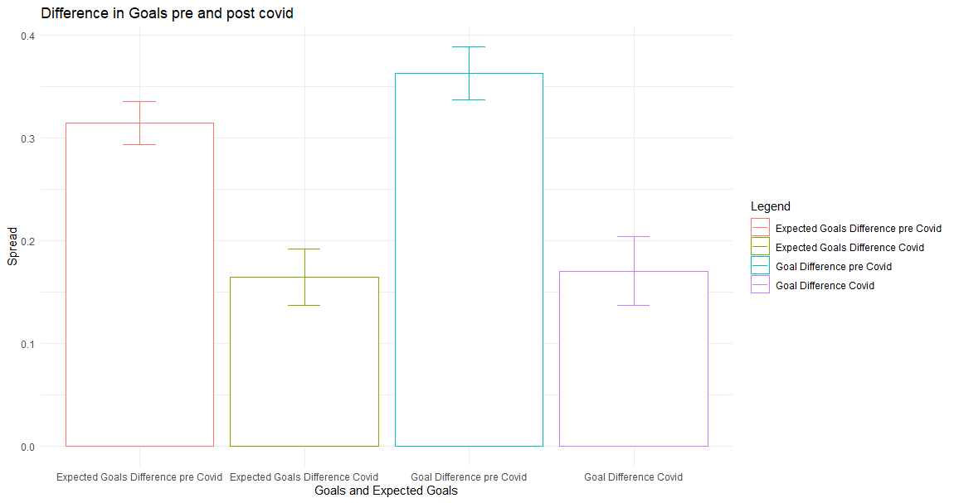

Also Referee decisions appear to be different in the situation of “ghost games”. Before the pandemic, referees gave more fouls, yellow cards and red cards to away teams, with each having a negative gap(home - away). However, after the pandemic, Yellow cards and Fouls have a positive gap, whereas the red card gap is still negative but seems to have decreased substantially in size.

**Figure 4 Comparison of Foul, Yellow card and Red card gap**

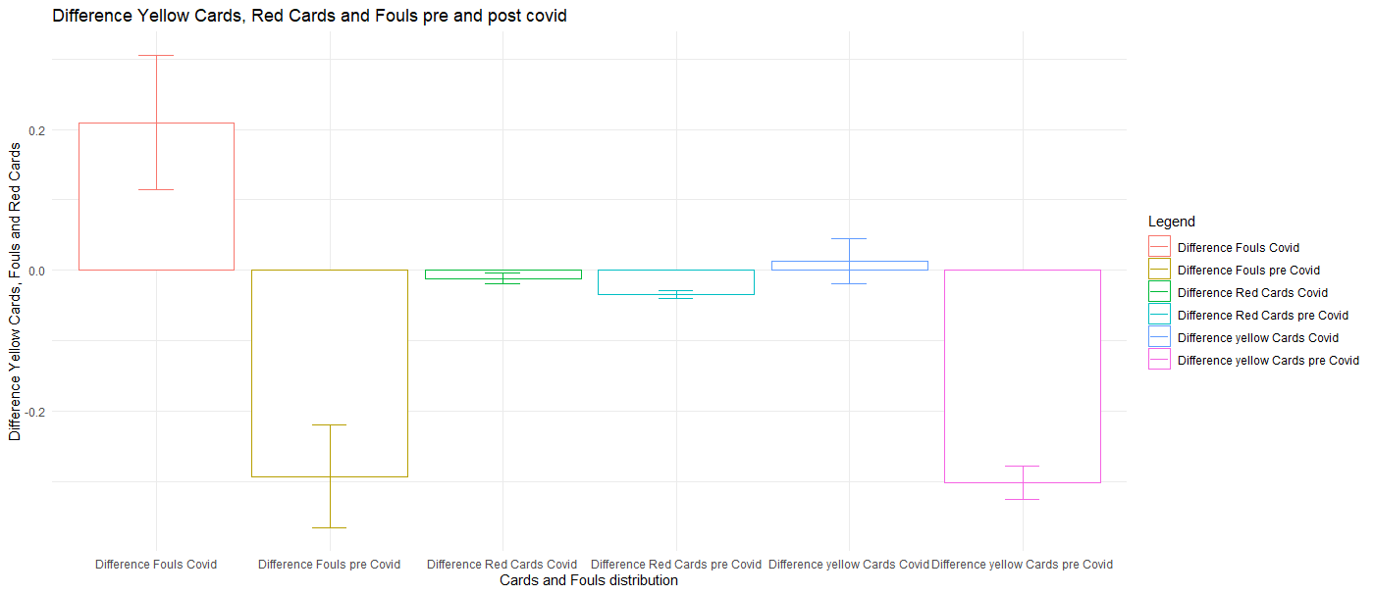

The visual inspection of the plots and the error bars hints at significant differences . However, pure visual inspection is not enought to warrant statistical significance. Therefore we proceed with statistical tests to examine whether home advantage has changed significantly following the covid-19 pandemic. Due to the continuous nature of our variables we used a Mann-Whitney U test, which handles our non-normal data better than traditional t-tests. For the percentage of home and away wins, due to their categorical nature we performed a chi square test of proportion comparison. Table 4 contains the mean pre and post covid-19 values for our variables of interest accompanied by p-values for the null hypothesis of equal distributions. The stars denote the significance level with * for p value<0.05, * * for p value < 0.01 and * * * for p value < 0.001

**Table 4 mean level differences pre and post covid**



To distinguish between differences in home and away performance. We provide the same table as before for the metrics from both Home and Away Perspective. As we can observe from table 5 and 6, the performance of home and away teams has changed significantly after the start of the covid-19 pandemic. The percentage of wins at home has declined 5 percent from 45 percent pre covid to 40 percent post covid whereas the percentage away wins have rose from 30 to 34 percent. The difference in their proportion is significantly different, which suggests that home advantage indeed has significantly decreased following the covid pandemic.

Also number of goals and points for home teams declined substantially. Away teams fare better in games behind closed doors compared to games with fans. Before the lockdown, away teams on average collected 1.14 points per game, scoring an average of 1.22 goals per game in the process. Since the lockdown, away teams have increased their points per game to 1.27, also increasing the amount of goals scored on average by 0.07 to 1.29 goals per game. With all numbers but expected goals for away teams significantly different for p value of < 0.001, there is clear evidence of a decrease in home advantage following the exclusion of home fans. The decrease in home advantage seem to come from both an increase in away team performance and a decrease in home team performance. Before the home team’s actual goals slightly outperformed their expected goals, whereas the away team’s actual goals where slightly below their expected goals value. Both goal values have converged closer to their expected goals value after the lockdown, which has lead to a significant reduction in home advantage.

**Table 5 mean levels home team metrics pre and post covid**



**Table 6 mean levels away team metrics pre and post covid**



Table 7 shows the results for referee decisions. Interesting to note is the insignificance for cards for home teams. It seems that rather than punishing home teams more severely, the gap in cards has mainly been reduced by a more lenient attitude towards away teams who receive significantly lower numbers of yellow and red cards since the start of the pandemic. A second interesting finding is despite the significant increase in fouls made by the home team, the number of cards has stayed relatively stable.

**Table 7 mean levels referee metrics pre and post covid**



## 3.5 Model

In the following section we examine whether difference in crowd support had a significant effect on team performance, checking for the effects of our moderators: occupancy, crowd size, foreigners in squad and team age. Furthermore we add the control variables for team strength and match importance. To correctly analyse causalities in our model, we require a moderated mediation analysis. Our first equation involves the path between our independent variable crowd support and our mediating variable, referee bias. We examine the moderating effect of Occupancy on the relationship between crowd support and referee bias. Furthermore, we control for team quality, match importance and Var availability. Our first model specifies the effect of our independent variables and our moderator on the mediator referee bias.

**Equation 1:** Foul Difference: *β0 + β1Covid + β2OccupancyRate + β3ForeignersShareDifference + β4Crowdsize + β5Covid*OccupancyRate + β6Covid * ForeignersShareDifference + β7Covid * Crowdsize + β8RatingDifference + β9ImportanceDifference + β10VAR + ɛ*

Subsequently, we integrate the mediator referee bias in the modelling of the relationship between our independent variable crowd support and dependent variable team performance, while incorporating our moderating variables into the model simultaneously. This leads to the following regression equation for the main effects analysis.

**Equation 2:** Percentage Points Home*= β0 + β1Covid + β2OccupancyRate + β3ForeignersShareDifference + β4Crowdsize + β5AgeDifference + β6 Covid*OccupancyRate + β7 Covid * ForeignersShareDifference + β8 Covid * Crowdsize + β9 Covid * AgeDifference + β10RatingDifference + β11ImportanceDifference + β12VAR + ɛ*

Since we want to assess multiple relationships in our model we deem a SEM model most suitable for our analysis. Hair, Black, Babin, Anderson and Tatham (2014) state the main advantage of SEM models vis-à-vis other powerful techniques such as Multiple regression and factor analysis is that SEM allows for the examination of multiple relationships together simultaneously. We use the lavaan package in R to conduct our analysis,

## Analysis and Findings

In this chapter we deploy our previously defined model on our dataset in order to examine the causal relationships within our conceptual framework. We estimate a linear regression within our Structural Equation model, and therefore we start by checking the assumptions for linear models to see whether our data is suitable for model deployment or that some data transformations are required.

## 4.1 Assumptions

**Normality**

In appendix 2b we show the results for our normality tests and qqnormality plots. The normality plots shows that our residuals are approximately normally distributed. To be sure that our intuition is correct we also test our data for normality. We performed 2 tests for normality with the gvlma package. As visible in table 8 our output shows an insignificant p-value for Skewness(0.11367) and a borderline significant p-value for Kurtosis(0.04375) for our first regression equation. For our 2nd regression equation, table 9 shows the results of the same 2 tests of normality. Appendix … shows the qqplot of the residuals for our second regression equation. Based on the multiple analysises of our data and our large sample size, we consider the possible non-normality of our residuals to not influence our results enough to warrant action, and therefore continue with interpreting our model.

**Linearity**

We user R’s built in stats package to check whether or not our model residuals follow a linear. The results in appendix 2c show that our data visually appears to be sufficiently linear, with the plot showing a horizontal red line, an indicator of linearity of residuals. Again, we use a combination of visual cues and statistical tests to confirm whether our residuals are sufficiently linear for continuing the analysis. For the statistical test we use the gvlma package that tests linear model assumptions. As visible in table 8 which shows the output for the gvlma for our Mediation model, we have a insignificant p-value(0.09) for Global Stat, which is a measure of linearity of the residuals of the model. Based on this insignificant test statistic in combination with the visualization of the residuals in appendix 2 make us assume that the assumption of linearity is not violated. For our second equation however, the assumption of linearity of is violated. Shown by a significant p value(0.000). This is one of the limitation of our study. This limitation is thoroughly in the discussion section of t

**Independence of errors:** Since our data is not time series data we can safely assume that this assumption is not violated for our analysis. (Hoechle, 2007)

**Multicolinearity**: When interpreting the correlation table in appendix 1b we see a few high correlations. Notably between Rating difference and our dependent outcomes, as well as correlation between Rating Difference and Importance Difference. Furthermore, there exists a correlation of 0.75 between occupancy rate and average attendance, which makes sense since these variables are quite closely related. To combat the problem of Multicolinearity we meancenter our Independent and Moderating variables. This is also a necessary step in moderation analysis since we include interaction effects into our analysis, which could give rise to multicolinearity(Iacobucci, Schneider, Popovich & Bakamitsos, 2017).

**Homoscedasticity:** The assumption of homoscedasticity is important for the ability to interpret standard errors of our model. We use the gvlma package in R to test our residuals for homoscedasticity, of which the results can be found in Table 5. As we observe from the graph, the test for Heteroscedasticity is insignificant(p-value 0.955), as such we conclude that the assumption of homoscedasticity is met in our model. For our second regression equation, the p value for Heteroscedasticity is also sufficiently high(p-value 0.94) to safely conclude that our data adheres to the assumption of homoscedasticity.

**Table 8 GVLMA assumption tests Equation 1(DV = FoulDifference)**

Value p-value Decision

Global Stat 7.646553 0.10542 Assumptions acceptable.

Skewness 2.452351 0.11735 Assumptions acceptable.

Kurtosis 4.250997 0.03923 Assumptions NOT satisfied!

Link Function 0.940023 0.33227 Assumptions acceptable.

Heteroscedasticity 0.003182 0.95502 Assumptions acceptable

**Table 9 GVLMA assumption tests Equation 2(DV = GoalDifference)**

Value p-value Decision

Global Stat 253.05579 0.00000 Assumptions NOT satisfied!

Skewness 0.75124 0.38608 Assumptions acceptable.

Kurtosis 248.47293 0.00000 Assumptions NOT satisfied!

Link Function 3.82617 0.05046 Assumptions acceptable.

Heteroscedasticity 0.00545 0.94115 Assumptions acceptable.

## 4.2 Results overview

Table 10 shows the results of our moderated mediation analysis, in a structured equation model.

**Table 10 Model estimates**



**Table 10 Mediating effect**



**Table 11 Fit indices**



Table 12 provides an overview of the fit indices for our SEM model. Our chi square statistic of 38.48 suggests that our model is overall significant, with an associated p-value of <0.001. To measure the goodness of fit of our model we use the standard that Dion(2008) provides in his paper onpreferred values for the major fit measures of SEM. He proposes that the TLI measure should approach 1 preferably, our TLI has a value of 0.81, which is not great. CFI should have a minimum value of 0.95 for a model to be considered a “good fit”, since our CFI measure has a value of 0.98, we conclude that also for this second metric our model seems to fit well. RMSEA is a measure of the difference in the sample data with what would be expected in the situation of a correct model. Thus for RMSEA the lower value the better, with 0.05 the generally accepted maximum value. Our value of 0.03 falls within the acceptable range. Overall our model seems to fit reasonably well, with 2 of the 3 major indices of model fit falling within acceptable ranges.

## 4.3 Hypotheses overview

In this section we interpret the results of our analysis and apply our results on our previously generated hypotheses.

Hypothesis 1: We find a significant effect of our dummy variable covid on team performance in the form of goal difference between the home and away side. Such that ghost games have had a significant influence on the difference in goals between Home and Away teams.

Hypothesis 1b: (Mijn attendance variable kreeg ik niet goed in het model dus heb hem voor nu eruit gehaald om wel resultaten voor de andere te kunnen laten zien maar ga later proberen deze wel erin toe te voegen)

Hypothesis 1c: We find no evidence for the moderating effect of crowd occupancy on the relationship between crowd support and team performance. Despite the interaction between occupancy and ghost games does not significantly affect team performance. However, we do find a significant direct effect of crowd occupancy on team performance, such that crowd occupancy appears to play a role in team performance.

Hypothesis 1d: Contrary to our expectations we conclude that player age is not a significant moderator of the relationship between crowd support and team performance. In other words, there is no significant difference in the influence of crowd support on team performance for younger or older teams. However, since previous finding such as those by van der Ven(2016) were relatively small, the insignificance of this moderator is not entirely unexpected.

Hypothesis 1e: The coefficients for our moderator Share of Foreigners is insignificant. Therefore we reject the hypothesis that thethe share of foreigners of a team moderates the the effect of crowd support on team performance. Clearly the difference in crowd support and atmosphere are not affected enough by the amount of foreigners playing on the field to play a role.

Hypothesis 2: We find evidence for a mediation effect of referee decisions on the relationship between crowd support and team performance. In our model, the direct and indirect effects all have significant p values. Apparently the effect of crowd support on team performance is mediated through referee decisions. Crowd support

Hypothesis 2b: Our results partially support our hypothesis on the increase in mediation effect of referee decisions on the relationship between crowd support and team performance for higher levels of crowd occupancy. There is a marginally significant effect of the interaction between crowd support and crowd occupancy(p -value 0.0593)

Hypothesis 2c: Our results do not support our hypothesis on the increase in mediation effect of referee decisions on the relationship between crowd support and team performance for higher levels of crowdsize. Similar to the insigificant effect of crowd occupancy on our mediating variable referee decisions, higher or lower levels of crowd support in the form of a bigger or smaller crowdsize apparently do not seem to matter significantly either.

Hypothesis 2d: -(Mijn attendance variable kreeg ik niet goed in het model dus heb hem voor nu eruit gehaald om wel resultaten voor de andere te kunnen laten zien maar ga later proberen deze wel erin toe te voegen)

For the control variables in our model we look at face validity to interpret the sign and significance of their coefficients. Firstly, in our mediation equation, we find a negative significant relationship for for Rating Difference and the difference in fouls between home and away teams. This makes sense since a higher Rating difference implies a stronger home team. A stronger home team is often expected to dominate the match and dominate possession, which then invites fouls from the away team in their attempts to win the ball. For importance difference we find an insignificant effect on foul difference. This implies that apparantely the importance of a match does not significantly alter the aggression and also tactical playing for teams, or that perhaps the differences in importances are not big enough to generate sufficient differences. For foul difference however we find a significant negative effect by the availability of the VAR. In other words, the availability of a VAR reduces the gap between the number of Fouls for home and away teams, which could be either because referees punish away teams less hashly or home teams more harshly. However, since the VAR dummy variable only differed for to two of 9 competitions in the season of 2018/19, the significant coefficient could also simply stern from differences in referees or playing styles partictular to these leagues that result in a different distribution of fouls between home and away teams.

In our direct effect model, for our control variables we found that for both Importance Difference and Rating Difference the effect to be significant for our dependent variable difference in goals. A higher importance difference leads to a higher level of goal difference. This intuitively makes sense, with a stronger home team playing a weaker away team, we would expect a higher number of goals relative to the away team.. We obtained similar results for importance difference. This appears to be a sensible result, if the match is relatively more important for the home team, the home team perhaps would have an extra incentive to win and increase performance to attain the goal of winning. This naturally translates into more goals scored relative to the away team. Our third covariate VAR shows a insignificant positive influence on difference in goals.

In the next chapter we summarize our main findings and provide a schematic overview of the answers to our hypothesis. Subsequently we use our results to generate managerial recommendations for managers working at football clubs. Finally we provide the limitations of this study plus some possible areas for future research.

## Conclusion and Discussion

## 5.1 Conclusions

Our model shows that

Table.. provides an overview of our hypotheses generated in chapter 2 and the evidence we find for the hypotheses in our analysis.

## 5.2 Managerial recommendations

Based on the estimations of our model

## 5.3 Discussion

Despite

## 5.4 Areas for future research

Based on the limitations of our study

# 6. Bibliography

1. Adcroft, A., Teckman, J., & Madichie, N. (2009). Management implications of foreign players in the English Premiership League football. *Management Decision*.
2. Agnew, G. A., & Carron, A. V. (1994). Crowd effects and the home advantage. International Journal of Sport Psychology
3. Allen, M. S., & Jones, M. V. (2014). The home advantage over the first 20 seasons of the English Premier League: Effects of shirt colour, team ability and time trends. *International Journal of Sport and Exercise Psychology*, *12*(1), 10-18.
4. Attrill, M. J., Gresty, K. A., Hill, R. A., & Barton, R. A. (2008). Red shirt colour is associated with long-term team success in English football. *Journal of sports sciences*, *26*(6), 577-582.
5. Boyko, R. H., Boyko, A. R., & Boyko, M. G. (2007). Referee bias contributes to home advantage in English Premiership football. Journal of sports sciences, 25(11), 1185-1194.
6. Brechot, M., & Flepp, R. (2020). Dealing with randomness in match outcomes: how to rethink performance evaluation in european club football using expected goals. Journal of Sports Economics,
7. Carmichael, F., & Thomas, D. (2005). Home-field effect and team performance: evidence from English premiership football. Journal of sports economics, 6(3), 264-281.
8. Clarke, S. R., & Norman, J. M. (1995). Home ground advantage of individual clubs in English soccer. Journal of the Royal Statistical Society: Series D (The Statistician), 44(4), 509-521.
9. Csikszentmihalyi, M. (1990). Flow: The psychology of optimal experience. New York, NY: Harper & Row.
10. Decroos, T., Bransen, L., Van Haaren, J., & Davis, J. (2019, July). Actions speak louder than goals: Valuing player actions in soccer. In *Proceedings of the 25th ACM SIGKDD International Conference on Knowledge Discovery & Data Mining* (pp. 1851-1861).
11. Dion, P. A. (2008). Interpreting structural equation modeling results: A reply to Martin and Cullen. *Journal of business ethics*, *83*(3), 365-368.
12. Endrich, M., & Gesche, T. (2020). Home-bias in referee decisions: Evidence from “Ghost Matches” during the Covid19-Pandemic. Economics Letters, 197, 109621.
13. Fédération Internationale de Football Association. (2007). FIFA Big Count 2006: 270 million people active in football. Zurich: Fédération Internationale de Football Association.
14. Fédération Internationale de Football Association.(2019), FIFA activity report 2018. Retrieved from https://www.fifa.com/who-we-are/official-documents/
15. Fischer, K., & Haucap, J. (2020). Does crowd support drive the home advantage in professional soccer? Evidence from German ghost games during the COVID-19 pandemic.
16. Galariotis, E., Germain, C., & Zopounidis, C. (2018). A combined methodology for the concurrent evaluation of the business, financial and sports performance of football clubs: the case of France. Annals of Operations Research, 266(1), 589-612.
17. Garicano, L., Palacios-Huerta, I., & Prendergast, C. (2005). Favoritism under social pressure. Review of Economics and Statistics, 87(2), 208-216.
18. Goddard, J. (2006). Who wins the football?. Significance, 3(1), 16-19.
19. Goumas, C. (2013). Home Advantage and Crowd Size in Soccer: A Worldwide Study. *Journal of Sport Behavior*, *36*(4).
20. Goumas, C. (2014). Home advantage in Australian soccer. *Journal of Science and Medicine in Sport*, *17*(1), 119-123.
21. Gutierrez, D. (2019). *Impact of Special Events and Fan-Player Bonding on Identified Fan Consumption-A Study of Professional Soccer in the United States* (Doctoral dissertation, Creighton University)
22. He, M., Cachucho, R., & Knobbe, A. J. (2015, September). Football Player's Performance and Market Value. In Mlsa@ pkdd/ecml (pp. 87-95).
23. Hoechle, D. (2007). Robust standard errors for panel regressions with cross-sectional dependence. *The stata journal*, *7*(3), 281-312.
24. Iacobucci, D., Schneider, M. J., Popovich, D. L., & Bakamitsos, G. A. (2017). Mean centering, multicollinearity, and moderators in multiple regression: The reconciliation redux. *Behavior research methods*, *49*(1), 403-404.
25. Inan, T. (2020). The Effect of Crowd Support on Home-Field Advantage: Evidence from European Football. Annals of Applied Sport Science, 0-0
26. Lago-Peñas, C., & Lago-Ballesteros, J. (2011). Game location and team quality effects on performance profiles in professional soccer. *Journal of sports science & medicine*, *10*(3), 465.
27. Lee, H., Gipson, C., & Barnhill, C. (2017). Experience of spectator flow and perceived stadium atmosphere: Moderating role of team identification.*Sport Marketing Quarterly, 26*(2), 87-98
28. Magen, Z. (1980). Encounter group effects on soccer team performance. *Small Group Behavior*, *11*(3), 339-344.
29. McSharry, P. E. (2007). Altitude and athletic performance: statistical analysis using football results. Bmj, 335(7633), 1278-1281.
30. Metelski, A., & Kornakov, K. (2021). Effect of lockdown owing to COVID-19 on players’ match statistics in Bundesliga. Journal of Physical Education & Sport, 21(1)
31. Müller, O., Simons, A., & Weinmann, M. (2017). Beyond crowd judgments: Data-driven estimation of market value in association football. European Journal of Operational Research, 263(2), 611-624.
32. Neave N, Wolfson S. Testosterone, territoriality, and the 'home advantage'. Physiol Behav 2003; 78: 269-75.
33. Neave N, Wolfson S. The home advantage: psychological and physiological factors in soccer. In: Lavalle D, Thatcher J, Jones MV, Eds. Coping and Emotion in Sport. New York, Nova Science Publishers 2004; 127-44.
34. Nevill, A. M., Newell, S. M., & Gale, S. (1996). Factors associated with home advantage in English and Scottish soccer matches. *Journal of sports sciences*, *14*(2), 181-186.
35. Nevill, A. M., & Holder, R. L. (1999). Home advantage in sport. Sports Medicine, 28(4), 221-236.
36. Nevill, A., Balmer, N., & Williams, M. (1999). Crowd influence on decisions in association football. The Lancet, 353(9162), 1416.
37. Nevill, A. M., Balmer, N. J., & Williams, A. M. (2002). The influence of crowd noise and experience upon refereeing decisions in football. Psychology of Sport and Exercise, 3(4), 261-272.
38. Peeters, T., & van Ours, J. C. (2021). Seasonal Home Advantage in English Professional Football; 1974–2018. *De Economist*, *169*(1), 107-126.
39. Pinnuck, M., & Potter, B. (2006). Impact of on‐field football success on the off‐field financial performance of AFL football clubs. Accounting & Finance, 46(3), 499-517.
40. Pollard, R. (1986). Home advantage in soccer: A retrospective analysis. Journal of sports sciences, 4(3), 237-248.
41. Pollard, R. (2008). Home advantage in football: A current review of an unsolved puzzle. The open sports sciences journal, 1(1)
42. Pollard, R., & Pollard, G. (2005). Long-term trends in home advantage in professional team sports in North America and England (1876–2003). Journal of sports sciences, 23(4), 337-350.
43. Pollard, Richard,(2006), Home Advantage in Soccer: Variations in its Magnitude and a Literature Review of the Inter-related Factors Associated with its Existence , Journal of Sport Behavior, Vol. 29, Iss. 2, 169-189.
44. Ponzo, M., & Scoppa, V. (2018). Does the home advantage depend on crowd support? Evidence from same-stadium derbies. Journal of Sports Economics, 19(4), 562-582.
45. Poulter, D. R. (2009). Home advantage and player nationality in international club football. *Journal of sports sciences*, *27*(8), 797-805.
46. Rodríguez, P., Humphreys, B. R., & Simmons, R. (Eds.). (2017). The Economics of Sports Betting. Edward Elgar Publishing.
47. Salminen, S. (1993). The effect of the audience on the home advantage. *Perceptual and motor skills*, *76*(3_suppl), 1123-1128.
48. Samagaio, A., Couto, E., & Caiado, J. (2009). Sporting, financial and stock market performance in English football: an empirical analysis of structural relationships. Journal Department of Management, ISEG/School of Economics and Management, Techincal University of Lisbon, Portugal.
49. Schwartz, B., & Barsky, S. F. (1977). The home advantage. Social forces, 55(3), 641-661.
50. Smith, D. R. (2003). The home advantage revisited: Winning and crowd support in an era of national publics. *Journal of Sport and Social Issues*, *27*(4), 346-371.
51. Strauss, B. (2002). Social facilitation in motor tasks: a review of research and theory. *Psychology of sport and exercise*, *3*(3), 237-256.
52. Sutter, M., & Kocher, M. G. (2004). Favoritism of agents–the case of referees' home bias. Journal of Economic Psychology, 25(4), 461-469.
53. Theodorakis Y, Goudas M, Papaioannou A, Eds. Book of long papers, 12th European Congress of Sport Psychology; 2007: Halkidiki, Greece: FEPSAC 2007; pp. 57-60.
54. Tilp, M., & Thaller, S. (2020). Covid-19 has turned home-advantage into home-disadvantage in the German Soccer Bundesliga. Frontiers in Sports and Active Living, 2, 165
55. Tucker, W., Mellalieu, D. S., James, N., & Taylor, B. J. (2005). Game location effects in professional soccer: A case study. International Journal of Performance Analysis in Sport, 5(2), 23-35.
56. Unkelbach, C., & Memmert, D. (2010). Crowd noise as a cue in referee decisions contributes to the home advantage. Journal of Sport and Exercise Psychology, 32(4), 483-498.
57. van de Ven, N. (2016). Does Player Age Affect the Home Advantage? Coaches’ Perceptions and Data from Professional Football.
58. Wetzel, H. A., Hattula, S., Hammerschmidt, M., & van Heerde, H. J. (2018). Building and leveraging sports brands: evidence from 50 years of German professional soccer. *Journal of the Academy of Marketing Science*, *46*(4), 591-611.

# 7. Appendix

1A: Assumptions test mediation model

Value p-value Decision

Global Stat 7.646553 0.10542 Assumptions acceptable.

Skewness 2.452351 0.11735 Assumptions acceptable.

Kurtosis 4.250997 0.03923 Assumptions NOT satisfied!

Link Function 0.940023 0.33227 Assumptions acceptable.

Heteroscedasticity 0.003182 0.95502 Assumptions acceptable

Appendix 1b:



Appendix 2a :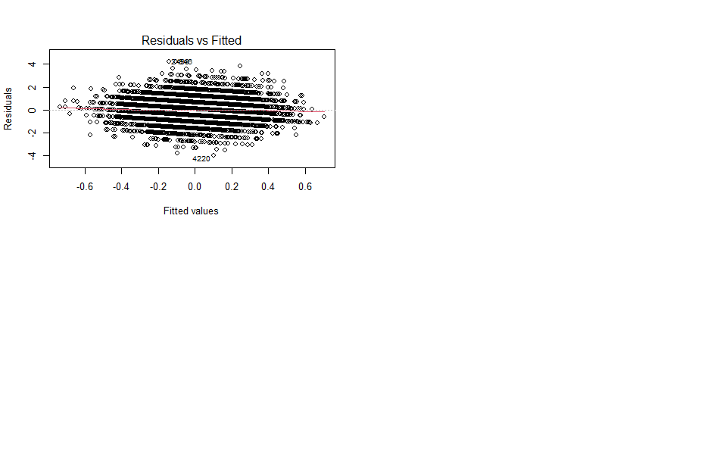

Appendix 2b: 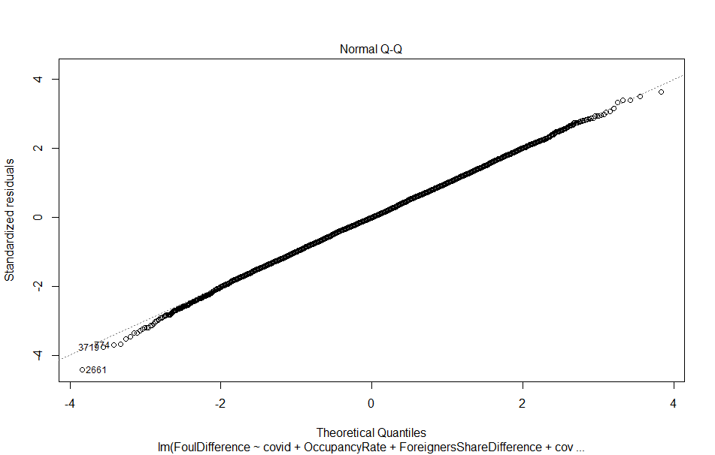

Appendix 2c:

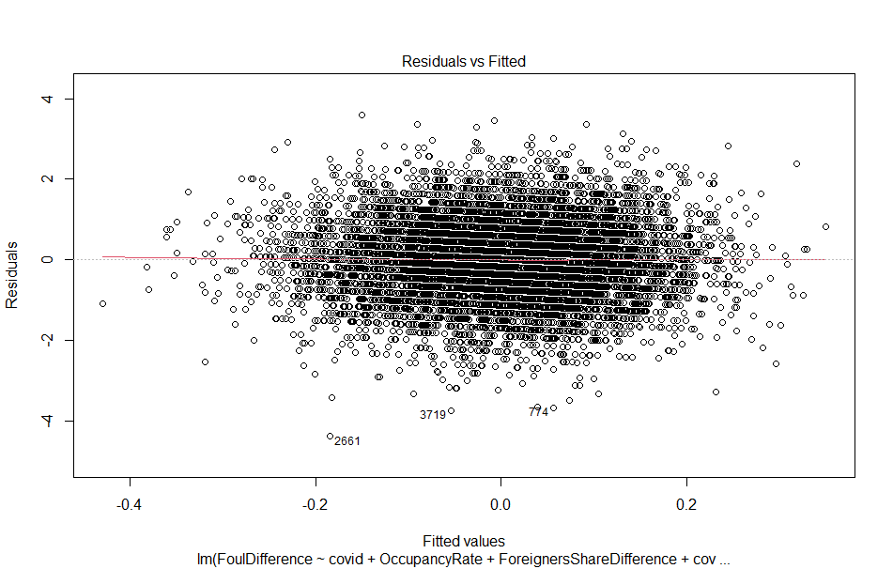

2d: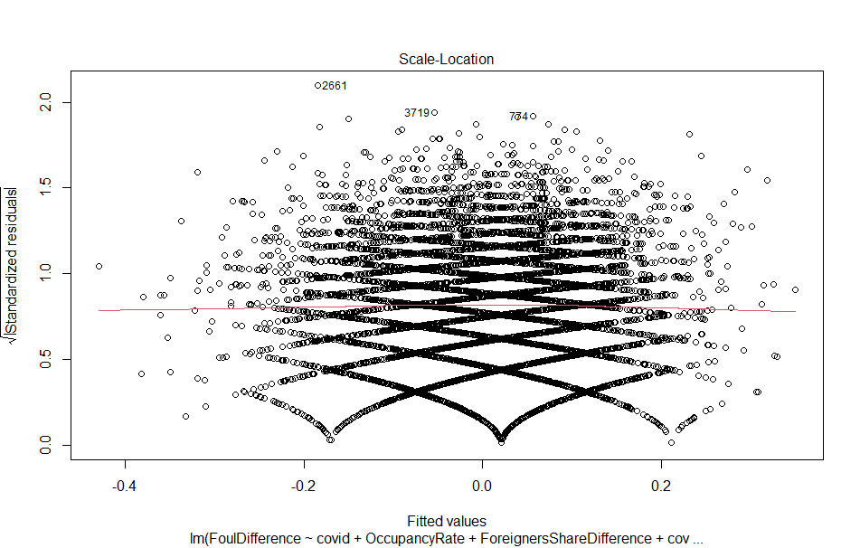

Appendix 3a: assumption test direct path

Value p-value Decision

Global Stat 253.05579 0.00000 Assumptions NOT satisfied!

Skewness 0.75124 0.38608 Assumptions acceptable.

Kurtosis 248.47293 0.00000 Assumptions NOT satisfied!

Link Function 3.82617 0.05046 Assumptions acceptable.

Heteroscedasticity 0.00545 0.94115 Assumptions acceptable.

Appendix 3b: Linearity residuals 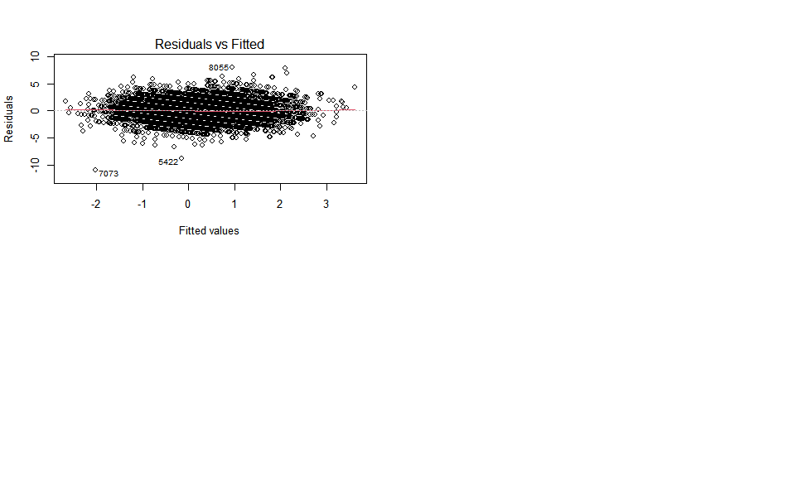

Appendix 3c: 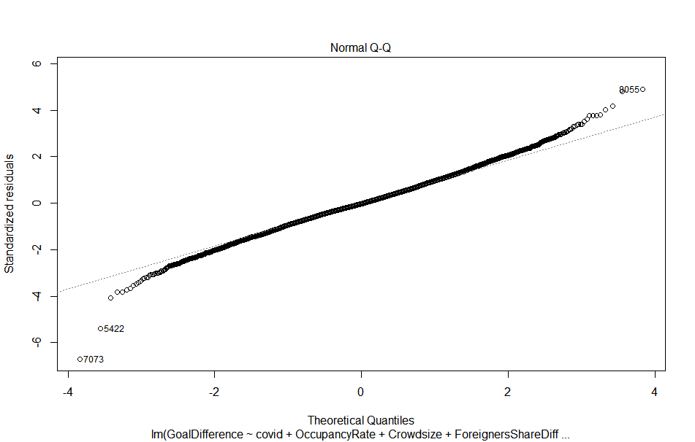

Appendix 3d: 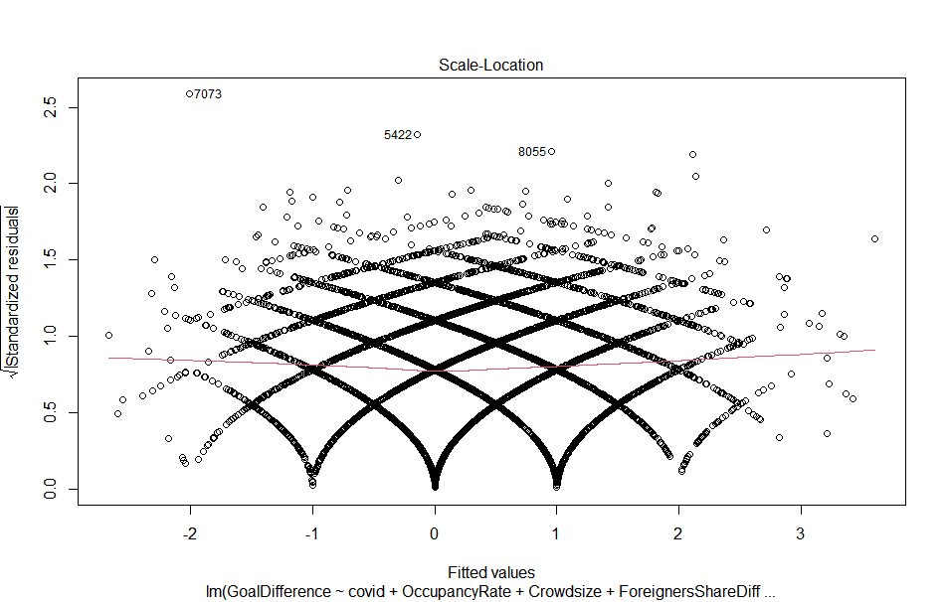

Appendix 3e: 

1. 2 https://en.wikipedia.org/wiki/Video_assistant_referee
2. <https://projects.fivethirtyeight.com/soccer-predictions/>